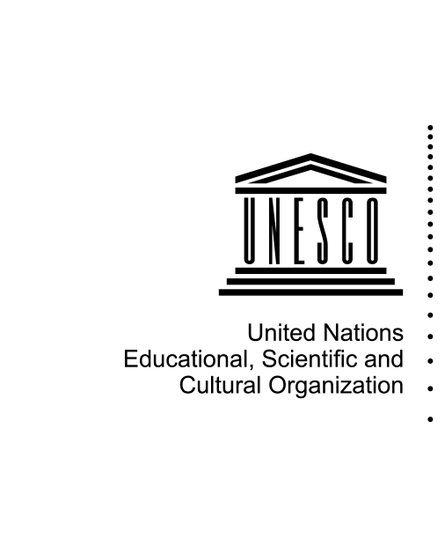

Nomination Form (후보 신청 양식)

본 양식은 2020 유네스코 소녀 및 여성 교육상 대한민국 후보 선정을 위한 양식입니다. 국내 후보 최종 선정 후, 유네스코본부 웹페이지(http://unesco.org/gwe)에 지정된 계정을 통해 접속하여 제출한 서류만 유효합니다.
본 양식은 작성 후 유네스코한국위원회로 제출해주시기 바랍니다. (soulgim@unesco.or.kr)

NOMINEE / CANDIDAT
Type of Nominee  Type de candidat |  | Organization / Organisation  Individual / Individu
Name of the Nominee *
Nom du candidat
Type of organization  Type d’organisation |  | Government / Gouvernement  International organization / Organisation internationale  Civil society organization / Organisation de la société civile  Private sector or business  Media / Médias  Academic or research institution / Institution d’enseignement supérieur ou de recherche  Education institution / Institution d’éducation  Other/ Autre: Specify
Name of the contact person
Personne à contacter
Title of the person
Fonction de la personne
E-mail *
Telephone number Numéro de téléphone
Mobile phone number
Postal address of candidate
Candidate’s country*
Description of the candidate*  Description du candidat |  | Please provide a summary description of 1,000 characters
Website
Site internet
PROJECT
Name of the project *
Project website
Abstract / Résumé *
How has your project advanced girls' and women's éducation? Explain its objectives,
methodology and key results in maximum 1,000 characters.
Specific contribution to the advancement of girls’ and women’s education *
Contribution spécifique à la promotion de l’éducation des filles et des femmes
Participation: Supporting girls to transition from primary education to lower-secondary education and to complete full basic education
Literacy: Supporting adolescent girls and young women to acquire literacy skills
Environment: Supporting the creation of a gender-responsive and safe teaching-learning environment
Teachers: Engaging teachers to be change agents with gender-responsive teaching attitudes and practices
Skills: Supporting girls and women to acquire knowledge/skills for life and work
Project Duration *
Indicate start and expected end date. Please note that only projects having been running for at
least TWO years will be considered.
Target group(s) for the project/programme / Groupes cibles pour le projet/programme*
Governments (national/sub-national/local)
Intergovernmental organizations
Civil society organizations
Private sector or business
Media
Academia or research institutions
Education institutions
Educators
Parents or caregivers
Girls
Women
Boys
Men
Other / Specify
Geographical coverage / Couverture géographique *
International / Internationale
Regional / Régionale
National / Nationale
Sub-national / Sous-nationale
Local / Locale
Covered countries*
Number of beneficiaries / Nombre de bénéficiaires *
Indicate thé number of beneficiaries to date. If thé project includes interventions that also
engage men and/or boys, ptease provide sex-disaggregated data.
Source(s) of funding *
Indicate thé funding source(s) (current and planned
Annual project budget
Please indicate 2019 cost in USD
Number of staff
Specify the number of staff involved in the project in 2019 (part-time or full time).
Achievements and Impact / Accomplissements et impact *
Please describe the major achievements and impact of thé project on girls' and women's
education, using concrete information such as feedback from participants, project scale up and expansion, number of site visits to thé project website or citations, in maximum 900 characters.
Innovation *
Please explain how thé project innovative in terms of thèmes, methods, channels used, or how it is generating gender-specific knowledge, tools and products to advance girls' and women's education, in maximum 900 characters

Sustainability / Durabilité *
Please explain what measures thé project is taking to ensure it is sustainable (e.g. addressing
institutionalisation, stakeholder engagement, capacity-development) to achieve a lasting
impact on girls' and women's éducation, in maximum 900 characters.
Outline the future strategy of your project
Describe the follow-up plan of the project, indicating information such as scale-up strategy,
target groups, duration and budget, in maximum 900 characters.
Use of Prize money
Indicate how the USD 50,000 Prize money would assist in the achievement of this strategy.

SUPPORTING MATERIALS (e.g. action plans, publications, videos, websites)
DOCUMENTS D'APPUI (par ex. plans d’action, publications, vidéos, sites internet)
Provide up to 10 links, with a brief description. To upload documents that are not available
online, please use the "Attach" function on the left corner above.
1.
2.
3.
4.
5.
6.
7.
8.
9.
10.
Please upload the Word/PDF version of this nomination form, if available
PERMISSION / PERMISSION
The candidate and the nominator agree that, even if the nominated project is not selected as
one of the two Prize laureates, a project summary and any photos provided via this form can be
published on the UNESCO website as good practices on girls' and women's education.
Yes/ Oui
No/ Non

SUBMISSION / SOUMISSION
Form completed by / Formulaire rempli par*
Permanent Delegation / Délégation permanente
NGO in official partnership with UNESCO / ONG en partenariat officiel avec l’UNESCO
National Commission / Commission nationale
Candidate / Candidat
Country / Pays
[List of Member States in English]
Transmit to the National Commission for validation
Transmit to the Permanent Delegation for submission
NOMINATING ENTITY
Member State / Etat membre
[List of Member States in English]
Non-governmental organization (NGO) / Nom de l’ONG
[List of NGOs in official partnership with UNESCO in English]
Name of submitting person Nom de l'auteur de la soumission *
Function / Fonction
E-mail *
Telephone / Téléphone
Supporting statement by the nominating entity / Déclaration d'appui de l'auteur de la soumission*
Please complete the following sentence, in maximum 300 characters “The nominee deserves to receive the UNESCO Prize for Girls’ and Women’s Education because…” Merci de compléter la phrase suivante, en 300 caractères maximum: « Le candidat mérite de recevoir le Prix UNESCO pour l’éducation des filles et des femmes parce que…»

